- Create storeDB and the products collection.
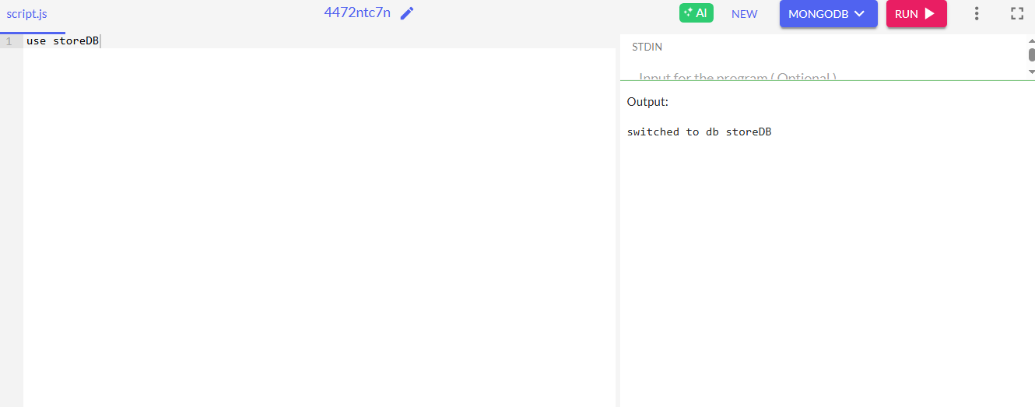

- Insert the 5 products using insertMany().
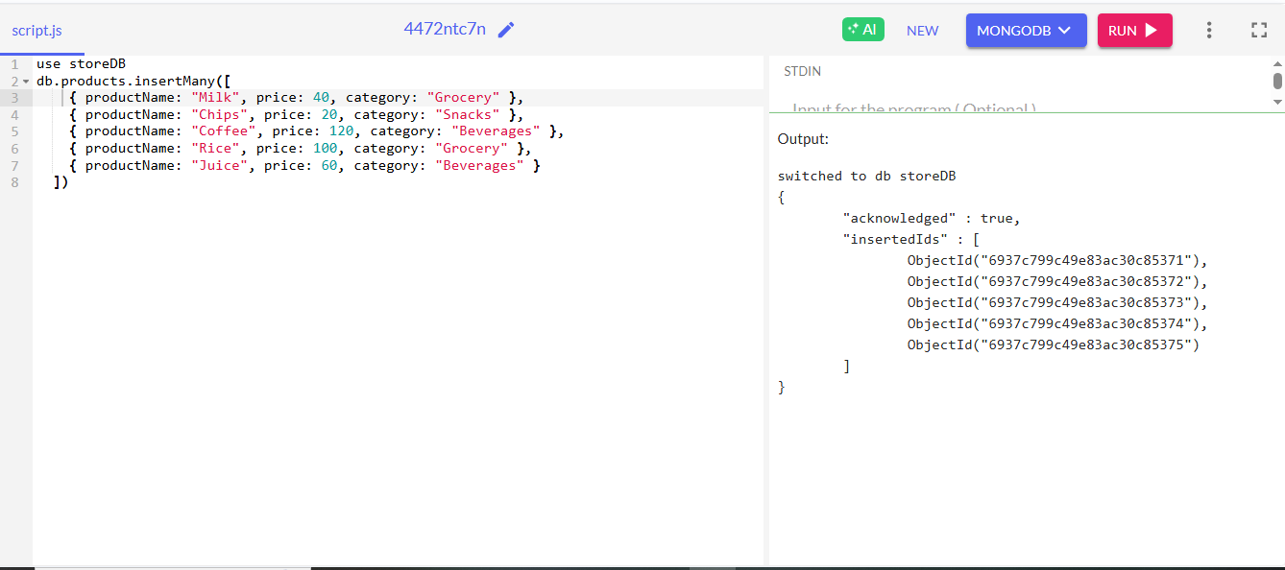
- Display all products.
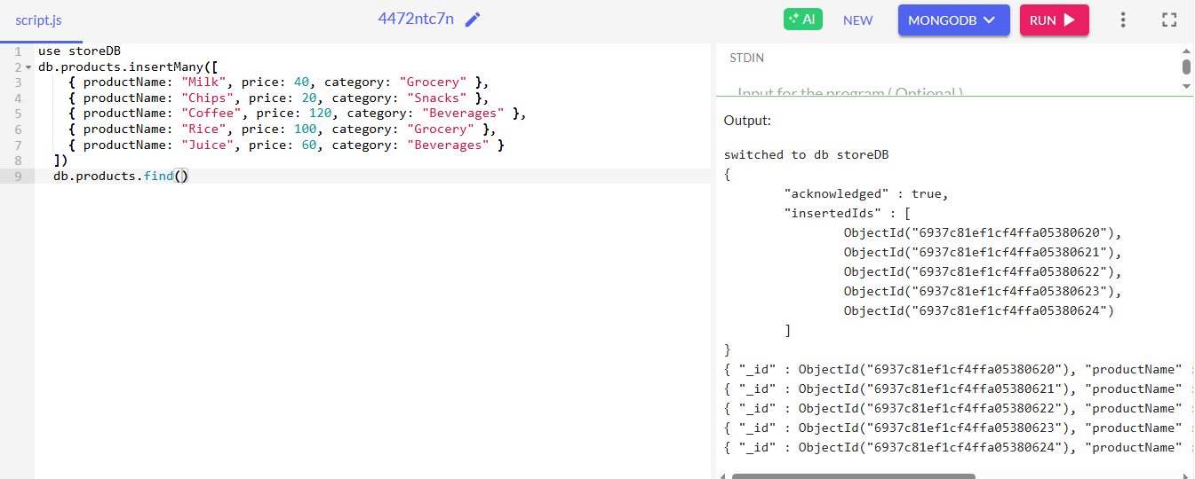

- Find the product with price = 100 using $eq.
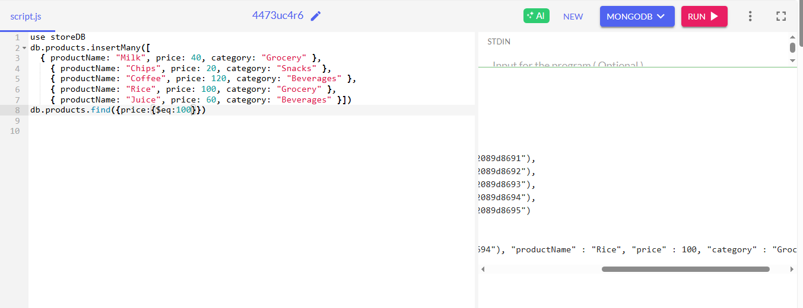

- List all products not in category “Snacks” using $ne.
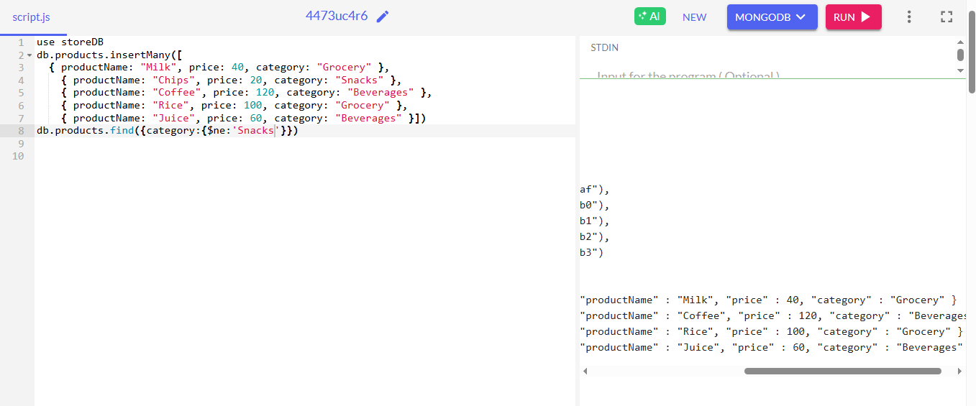

- Find products with price > 50 using $gt
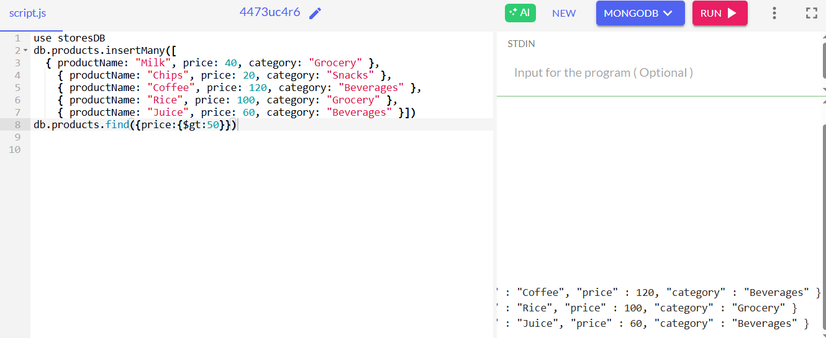

- Find products with price < 40 using $lt.
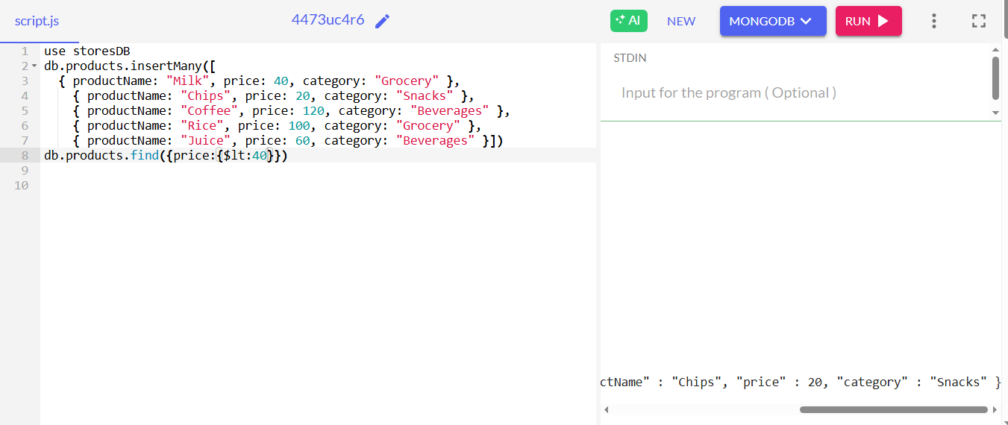

- Find all products whose category is Grocery or Beverages using $in
